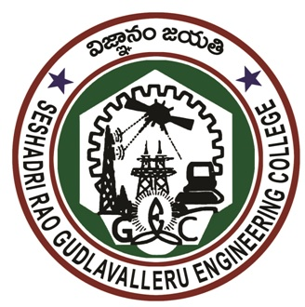

SESHADRI RAO
GUDLAVALLERU ENGINEERING COLLEGE
(An Autonomous Institute with Permanent Affiliation to JNTUK, Kakinada)
Seshadri Rao Knowledge Village, Gudlavalleru

Application Form for “SRGEC Ratnas - Distinguished Alumni Award”
The Distinguished Alumni Award (DAA) is the highest honour bestowed upon alumni of Seshadri Rao Gudlavalleru Engineering College, erstwhile Gudlavalleru Engineering College, Gudlavalleru who have demonstrated significant achievements in their chosen professions, earned high respect among their colleagues, and had a national or international impact. To apply for the DAA, please complete the form given below and submit through email to srgecratnas@gecgudlavalleru.ac.in on or before 15-11-2023.

- Category Applying (Tick the relevant one):

Recent Pass port size photo

- Excellence in Academics and Other Walks of Life

- Technology Innovation Excellence

- Entrepreneurial and Managerial Excellence

Name:
- Date of Birth:

Present Position:
- Address:

Official: | Residential:
Mobile: | Whatsapp No.:
Email: | LinkedIn ID:

Degrees Obtained at SRGEC:

Degree | Year | Branch/Specialization | Awards/Distinctions

- Other Academic Qualifications:

Degree | Year | Institution | Awards/Distinctions

Career Profile and Professional Achievements:

Period |  | Position Held | Organization/ Institution | Role | Achievements
From | To

- Recognitions/ Achievements/ Honours (List in Chronological Order):

Most Distinctive Contributions / Accomplishments / Achievements:

The Significance and/or the Societal Impact of Distinctive Contributions / Accomplishments given in Item No.10:

Specific Outstanding Accomplishments Meriting the Award:

Fellowship of National / International Professional Bodies:

I certify that the above information is correct.

Place: Signature of the Applicant
Date:

Enclosures: Brief CV and Supporting Documents in Soft Copy Form.

